DOT/FAA/TC-xx/xx  Federal Aviation Administration  William J. Hughes Technical Center  Aviation Research Division  Atlantic City International Airport  New Jersey 08405 | Airport Pavement Multiple-Event Roughness Detection and Evaluation  January 2026  Final Report  This document is available to the U.S. public  through the National Technical Information  Services (NTIS), Springfield, Virginia 22161.  This document is also available from the  Federal Aviation Administration William J. Hughes  Technical Center at actlibrary.tc.faa.gov.  U.S. Department of Transportation  Federal Aviation Administration

NOTICE

This document is disseminated under the sponsorship of the U.S. Department of Transportation in the interest of information exchange. The United States Government assumes no liability for the contents or use thereof. The United States Government does not endorse products or manufacturers. Trade or manufacturer's names appear herein solely because they are considered essential to the objective of this report. The findings and conclusions in this report are those of the author(s) and do not necessarily represent the views of the funding agency. This document does not constitute FAA policy. Consult the FAA sponsoring organization listed on the Technical Documentation page as to its use.

This report is available at the Federal Aviation Administration William J. Hughes Technical Center’s Full-Text Technical Reports page: actlibrary.tc.faa.gov in Adobe Acrobat portable document format (PDF).
Technical Report Documentation Page
1. Report No.  DOT/FAA/TC-xx/xx | 2. Government Accession No.  None |  | 3. Recipient's Catalog No.
4. Title and Subtitle  Develop the Capability for ProFAA Software to Simulate Takeoff and Landing Operations for Seven Classes of Aircraft. |  |  | 5. Report Date  January 2026
 |  |  | 6. Performing Organization Code
7. Author(s)  Tony Gerardi, Michael Gerardi |  |  | 8. Performing Organization Report No.
9. Performing Organization Name and Address  APR Consultants, Inc.  27 Oaklawn Ave.  Medway Ohio 45341 |  |  | 10. Work Unit No. (TRAIS)
11. Contract or Grant No.
692M15-24-T-00006
12. Sponsoring Agency Name and Address  Department of Transportation  Federal Aviation Administration  Office of Airports Safety and Standards  800 Independence Ave. SW  Washington, DC 20591 |  |  | 13. Type of Report and Period Covered  Final Report
14. Sponsoring Agency Code
AAS-100
15. Supplementary Notes
The FAA Airport Technology Research and Development Branch Contracting Officer Representative (COR) is Dr. Richard Ji.
16. Abstract
FAA roughness software, ProFAA, provides airports with a tool to comply with Advisory Circular 150/5380-9. This runway roughness specification provides guidance to the airfield pavement community to address runway roughness issues. ProFAA is designed to evaluate aircraft dynamic response on airport pavements. The current version could only conduct constant speed taxi simulations on five older commercial aircraft (DC-9, DC-10, Boeing-727, Boeing-737, and Boeing 747).
This project added Takeoff and Landing simulation capability to ProFAA. In addition, seven classes of modern commercial and GA aircraft can be simulated. The classes are separated by aircraft weight and landing gear spacing which are primary factors in determining how aircraft respond to pavement unevenness.

17. Key Words  ProFAA, Airport Pavement Roughness, Airport Pavement Management, Runway/Taxiway Roughness Evaluation, Aircraft Dynamic Response, Multiple-Bump Detection. |  | 18. Distribution Statement  This document is available to the U.S. public through the National Technical Information Service (NTIS), Springfield, Virginia 22161. This document is also available from the Federal Aviation Administration William J. Hughes Technical Center at actlibrary.tc.faa.gov.
19. Security Classif. (of this report)  Unclassified | 20. Security Classif. (of this page)  Unclassified |  | 21. No. of Pages  54 | 22. Price

Form DOT F 1700.7 (8-72) Reproduction of completed page authorized
ACKNOWLEDGEMENTS
The authors would like to thank the following people for their contributions to this effort.

Applied Research Associates:
Scott Murrell, Anthony Kuncas, Martina Dennis, and Robert Norton

Federal Aviation Administration:
Dr. Richard Ji, and Murphy Flynn

Contents

LIST OF TABLES 5
LIST OF ACRONYMS 6
EXECUTIVE SUMMARY 7
Introduction 8
Approach 10
Development ProFAA-SD – “Equations of Motion” 11
Development of Subroutine “Aircraft Selection” 13
Populating “Aircraft Selection” with Specific Data 13
Modeling the Equations of Motion (EOM) 13
Model Assumptions 21
Model Validation 21
Interface Development 23
User Interface 24
Conclusions 31
Observations and Lessons Learned 32
Potential Additions to ProFAA 32
Recommendations 33
References 34
Appendix A: Results of Field-Testing MER Analysis 35

Table of Figures
Figure 1. Pavement Preservation Loop 8
Figure 2. ProFAA "Calls Up" Aircraft Simulation Subroutines. 11
Figure 3. Illustration of the forces acting on the simulation model (Class RJ shown). 12
Figure 4. Mathematical Illustration of Forces (Class XL shown - with wing and body MLG) 12
Figure 5. Components of an Oleo-Pneumatic Landing Gear Strut. 14
Figure 6. Load-Stroke Curve for Class RJ Nose Landing Gear. 15
Figure 7. ProFAA Screen Shot Demonstrating Damping on a Class RJ Aircraft 16
Figure 8. Illustration of a Type VII Aircraft Tire Qualification Test 17
Figure 9. Screen Shot of Typical Takeoff Field Length Required Vs Weight and Field Elevation 20
Figure 10. Screen Shot of Typical Landing Field Length Required 20
Figure 11. Screen Shot of ProFAA Class WB 167 Kt Taxi Simulation: (05 Direction) 22
Figure 12. Screen Shot of ProFAA Constant Speed Taxi Simulation: (23 Direction) 23
Figure 13. Selecting Aircraft Simulation Wizard from ProFAA main Interface 24
Figure 14. Screenshot of Aircraft Simulation File Upload Window 25
Figure 15. Aircraft Simulation Wizard, Page 1: Aircraft Selection 26
Figure 16. Aircraft Simulation Wizard, Page 2: Input Variables and Simulation Type 27
Figure 17. Aircraft Simulation Wizard, Page 3: Simulation Input Summary 27
Figure 18. Aircraft Simulation Wizard, Page 4: Simulation Output Summary 28
Figure 19. Aircraft Simulation Wizard: Plot Window 30
Figure 20. Aircraft Simulation: "Insufficient Rnway Length for Takeoff!" message 31
Figure 21. Screen Shot of a Roughness Analysis of Runway R212. 36
Figure 22. Screen Shot of a Roughness Analysis of Runway R41. 37
Figure 23. Screen Shot of a Roughness Analysis of Runway R13. 38
Figure 24. Screen Shot of a Roughness Analysis of Runway R42. 38
Figure 25. Screen Shot of a Roughness Analysis of Runway R43. 39
Figure 26. Screen Shot of a Roughness Analysis of Runway R301. 40
Figure 27. Screen Shot of a Roughness Analysis of Runway R302. 41
Figure 28. Screen Shot of a Roughness Analysis of Runway R303. 42
Figure 29. Screen Shot of a Roughness Analysis of Runway R401. 42
Figure 30. Screen Shot of a Roughness Analysis of Runway R402. 43
Figure 31. Screen Shot of a Roughness Analysis of Runway R501. 44
Figure 32. Screen Shot of a Roughness Analysis of Runway R503. 45
Figure 33. Screen Shot of a Roughness Analysis of Runway R504. 46
Figure 34. Screen Shot of a Roughness Analysis of Runway R44. 47
Figure 35. Screen Shot of a Roughness Analysis of Runway R601. 48
Figure 37. Screen Shot of Runway R701 MER Analysis. 49
Figure 38. Screen Shot of a Class RJ Takeoff Simulation on Runway R701. 50
Figure 39. Screen Shot of MER Results of Runway R801. 51
Figure 40. Taxiway T38 MER Operation Not Successful in Detecting Pilot Reported Roughness. 51
Figure 42. PSD Plot of Taxiway T38. 52
Figure 43. Screen Shot of Taxiway T39. 53

LIST OF TABLES
Table 1. Classes of Aircraft that the Upgraded ProFAA can Simulate. 9
Table 2. Pneumatic Force Component Values. 15
Table 3. Tire Data for Each Aircraft Class. 17
Table 4. Comparison of Airport Planning Manual Values to ProFAA Values. 18
Table 5. Weight and Pitch Inertia Values for Multiple Configurations. 19
Table 6. Comparison of Measured CG Response to Simulated Response. 23
Table 7. ProFAA Roughness Limits of Acceptability. 35

LIST OF ACRONYMS
ABS Absolute value
AC Advisory Circular
APR APR Consultants, Inc.
APRas Airport Pavement Roughness Assessment Software
BBI Boeing Bump Index
CG Center of Gravity
CL Centerline
CP Cockpit
EOM Equations of Motion
FAA Federal Aviation Administration
G or (g) Acceleration of gravity
Iyy Mass Moment of Inertia - Pitch
MER Multiple-Event Roughness
MLG Main Landing Gear
NLG Nose Landing Gear
PCC Portland Concrete Cement
PI-100 Profile Index for a 100-Foot Simulated Profilograph
PI-25 Profile Index for a Standard 25-Foot Profilograph
PMP Pavement Management Program
PPL Pavement Preservation Loop
PSD Power Spectral Density
RQF Ride Quality Factor
RSE Rolling Straightedge

EXECUTIVE SUMMARY
This report describes the process used to develop a takeoff and landing simulation capability for the Federal Aviation Administration’s (FAA) roughness evaluation software, ProFAA. Two subroutines were developed that are called up by ProFAA when aircraft simulation is selected. ProFAA-SD contains the equations of motion (EOM) needed to compute the aircraft response to a user selected runway or taxiway profile. Aircraft Selection allows the user to select the class of aircraft to be simulated.
Profile: The runway or taxiway profile to be evaluated can be selected the same as in the current version of ProFAA or in the Aircraft Simulation File Upload window.
When the user selects Aircraft Simulation, several window wizards will appear that allow the user to set the conditions to be simulated.
- Type of Operation: Takeoff, Landing, or Constant Speed Taxi
- Ambient Conditions: Field Elevation, Temperature, Headwind Component,
- Simulation Starting Point: Set by the user: (i.e. displaced threshold, intersection takeoff, landing touchdown location, etc.)
A summary of the simulated conditions is displayed; the simulation results are stored in an output file and then plotted.
The plots are:
- Pavement profile as it is encountered by the main landing gear
- Cockpit vertical acceleration
- Center of gravity (CG) vertical acceleration
- Nose landing gear (NLG) vertical force
- Main landing gear vertical force
- Speed as the aircraft accelerates or decelerates down the runway
The cockpit and CG acceleration scaling defaults to a 1.0g value. If 1.0g is exceeded, it advances in .5g increments. Landing gear force plots are scaled automatically based on peak values.
Seven classes of aircraft can be simulated. The classes of aircraft are intended to provide a representative cross section of commercial aircraft. General aviation is currently represented with one propeller driven aircraft and one private jet model. The commercial classes are separated by weight and landing gear spacing which are primary factors in determining how aircraft respond to pavement unevenness.
Adding takeoff and landing simulation capability to ProFAA allows the user to conduct realistic operations on measured profiles. This enables the user to make informed decisions regarding the need for pavement corrective action on roughness events. Bump location is critically important in determining how an aircraft will respond. A 100-foot-long bump encountered at 20 knots will produce much less response than if it is encountered at 120 knots. Consequently, to compute realistic results, the speed of encounter is important. This established the need to simulate an accelerating aircraft (during takeoff with engine thrust) and a decelerating aircraft (during landing with brakes and reverse thrust).
This report also contains the approach and rationale for decisions in developing the EOM and the aircraft class selection.
The changes made to ProFAA enhance the FAA’s pavement preservation goals and complement recent proposed advances in pavement management such as the Pavement Preservation Loop (PPL).

Introduction
Pavement preservation is a strategic goal of the FAA. Figure 1 illustrates a proposed “Pavement Preservation Loop”: a process of integrating recent additions to ProFAA, such as the MER (Multiple Event Roughness), and proposed advances to FAA Advisory Circulars regarding airport pavement management and airport pavement roughness assessment.
Figure 1. Pavement Preservation Loop
To make the pavement preservation process work, changes to ProFAA were required. The current ProFAA aircraft simulation software can only simulate constant speed taxi operations. While this is helpful in identifying how an aircraft will respond to runway roughness, it is not a realistic operation. Takeoff and landing simulations that accelerate and decelerate down the runway are needed to accurately predict how a given aircraft class will respond. The speed that a bump or series of bumps is encountered is a critical factor in determining the response. Many parameters can impact the aircraft’s speed; they include the dynamic forces of engine thrust, aerodynamic lift and drag, brakes and reverse thrust. In addition, the effects of field elevation, wind, and temperature should be included in the upgraded version of ProFAA. Finally, operations from a displaced threshold may be a requirement in assessing the roughness of a runway or taxiway.
The current ProFAA version is also limited to five older aircraft types. The revised ProFAA software will simulate seven “Classes” of aircraft. The classes are separated by weight and gear spacing and represent the air transport fleet from general aviation to very large commercial aircraft. The aircraft classes that can be simulated are shown in Table 1.
Table 1. Classes of Aircraft that the Upgraded ProFAA can Simulate.
There are three types of roughness as described in (ref 1 – Phase 1 report).
- Type 1—Shock: The result of encountering a sharp change in elevation such as a single-step-type bump, a faulted slab, spall, or very short wavelength bump or dip.
- Type 2—Short Wavelength: A clear cutoff length that defines short versus long wavelength roughness does not exist; however, short wavelength roughness can be defined as roughness that minimally impacts the aircraft as a whole. Each strut tends to react to the localized roughness independently, e.g., the response at the main landing gear (MLG) has a minimal effect on the response at the nose landing gear (NLG) for Type 2 roughness and vice versa.
- Type 3—Long Wavelength: Long wavelength roughness can be defined as bumps and dips that excite the aircraft’s rigid body modes of vibration (pitch and plunge). This type of roughness couples the MLG and NLG responses. The MLG response will impact the NLG response and vice versa.
Type 3 roughness is of less concern for taxiways since speeds are low and controllable. All three types of roughness can affect aircraft response on runways where speed is high during takeoff and landing.
How an aircraft responds to Types 1, 2, and 3 roughness is impacted by several variables.
They include the weight of the aircraft, the spacing between the NLG and the MLG, the speed at which the roughness is encountered, the length of the bump(s) and the spacing between the bumps. The variables are coupled. E.g. a bump, type 3 in particular, encountered at MLG can impact the NLG and vice versa. This results in modeling coupled-non-linear differential equations and explains the need for a simulation model that accelerates and decelerates.
In general, commercial aircraft landing gear are typically designed with a load factor of “2g” for the MLG (with the most aft CG at max gross weight), and a load factor of “3g” for the NLG (with the most forward cg at max gross weight). Landing gear struts and their attached structure are designed for high loads and are made of high strength steel. They are also subject to accumulated fatigue damage. The useful life of landing gear struts can be extended if runway and taxiway loads are minimized. Just as smooth runways last longer, so do the aircraft that operate on them.
Consequently, extending the life of the pavement with the Pavement Preservation Loop will also extend the life of the aircraft and reduce operational and maintenance costs.

Approach
The runway roughness evaluation software package, APRas was used to guide the development of the upgraded version of ProFAA. APRas has been used for over 30 years to simulate aircraft response to runway roughness. It has successfully located and quantified roughness events for hundreds of runways and taxiways, national and international. APRas provided a time-tested platform to develop the equations of motion for ProFAA. Finally, specific aircraft data collected and used in APRas was available to develop models that represent the seven classes of aircraft.
ProFAA already has the capability to simulate aircraft response to runway roughness, but it is limited to constant speed taxi operations only. In addition, ProFAA is limited to the simulation of five older commercial aircraft.
The primary objectives of this ProFAA update are to:
- Add takeoff and landing simulation capability to ProFAA.
- Add “classes” of aircraft that are a representative cross section of the modern fleet.
- Add a user interface that allows the user to input influencing variables such as field elevation, temperature, wind, designate displaced threshold, etc.
The approach for upgrading ProFAA was to develop two subroutines using APRas as a guide. One subroutine is called ProFAA-SD. It contains the equations of motion (EOM) that apply to all aircraft classes. The other is called Aircraft Selection-SD. It contains specific aircraft data that describes each of the aircraft classes. These subroutines are called up by ProFAA when an aircraft simulation operation is to be performed.
A user interface was developed that allows the user to input contributing factors. Variables such as field elevation, ambient temperature, headwind, and the starting location on the runway or taxiway can have a significant impact on aircraft response. In addition, these user controls can be useful in determining if corrective action is needed to maintain an acceptable level of smoothness. Figure 2 is an illustration of the concept used in ProFAA when a takeoff and landing operation is selected.

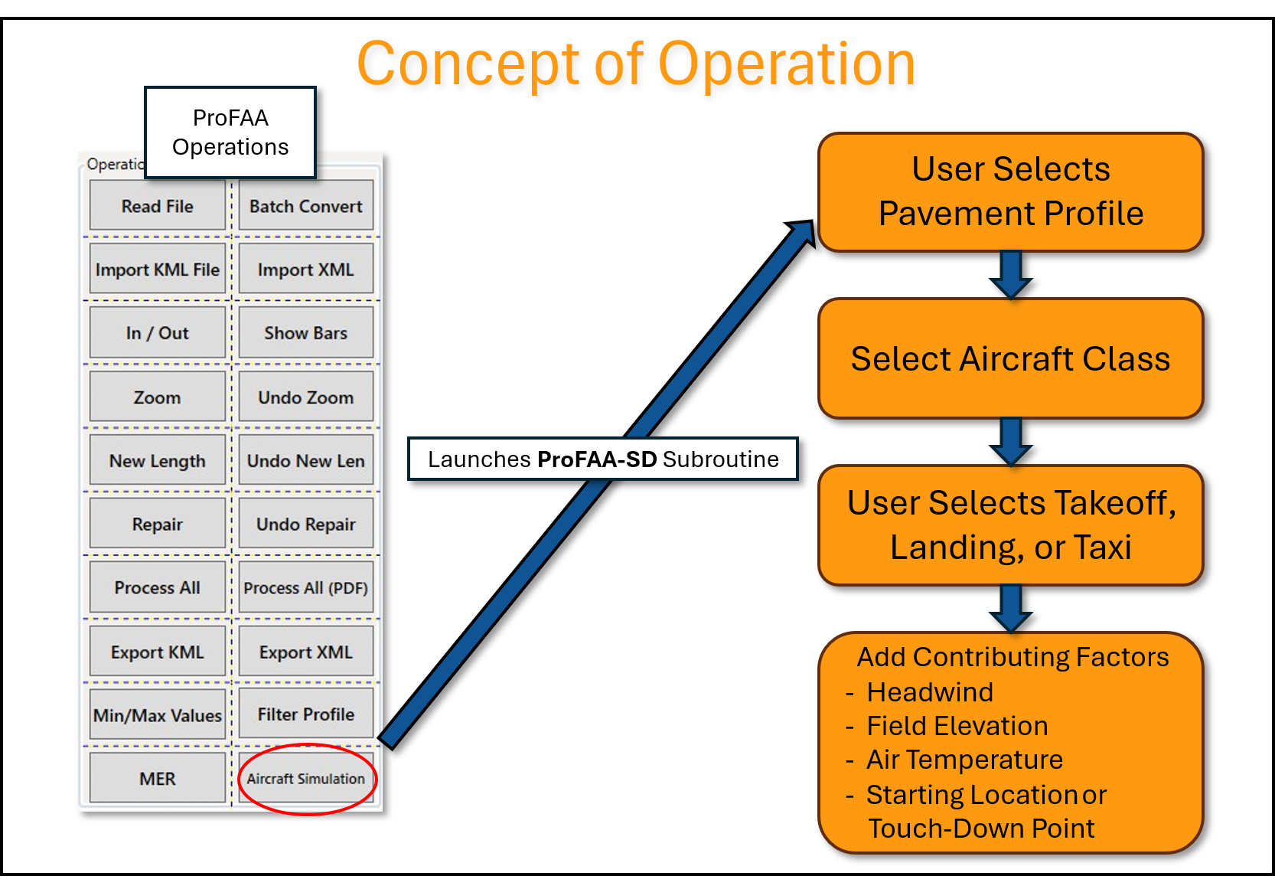
Figure 2. ProFAA "Calls Up" Aircraft Simulation Subroutines.

Development ProFAA-SD – “Equations of Motion”
Figure 3 is an illustration of the basic forces that are simulated using the Class RJ as an example. All aircraft classes have the same general forces acting on them but with data specific to each class. The vibration model has pitch, plunge, and forward translation degrees of freedom.
Figure 4 is an illustration of the components that define those individual forces. The corresponding equations of motion are derived using these forces to mathematically compute the response of the aircraft.
Figure 3. Illustration of the forces acting on the simulation model (Class RJ shown).
The equations of motion (EOM) that define these forces are coupled, non-linear differential equations. The EOM are solved using a Taylor series expansion with a time step size of .001 seconds.

Figure 4. Mathematical Illustration of Forces (Class XL shown - with wing and body MLG)

Notations:
Z_{p} Vertical displacement of the profile
W₁ Weight of the un-sprung mass at gear 1
Z₁ Vertical displacement of W₁
F_{T1} Tire force at gear 1
I_{yy} Pitch moment of inertia (mmi)
q Structural flexibility
ϴ Pitch angle
Z Vertical translation of the CG

Development of Subroutine “Aircraft Selection”
When developing ProFAA-SD takeoff and landing simulation capability, there was a need for a subroutine to store data that describes the various aircraft classes. When data about a specific aircraft class is required, the software calls the Aircraft Selection subroutine to obtain the data of that specific aircraft class for the given aircraft simulation operation. This same code structure was used to develop ProFAA and the Aircraft Selection subroutine. Aircraft Selection was designed to have all variables necessary to communicate the proper aircraft data to the EOM. Populating the Aircraft Selection subroutine with specific data for each aircraft class was a separate task.

Populating “Aircraft Selection” with Specific Data
Seven classes of aircraft in Aircraft Selection represent the wide range of the fleet of aircraft that currently operate on these runway and taxiway surfaces. The primary factors that separate the seven classes of aircraft are weight and landing gear spacing. When a specific class is selected by the user, a specific set of data is loaded into ProFAA. This detailed data describes the landing gear struts and tires, overall dimensions, weights and inertias, aerodynamic data, etc.

Modeling the Equations of Motion (EOM)
Roughness events on an airport pavement are transmitted through the tires and landing gear struts into the aircraft structure. The landing gear are modeled as typical oleo-pneumatic struts with four basic components.
- Pneumatic Force - The compression of nitrogen is the primary strut force during taxi, takeoff roll and landing rollout.
- Hydraulic Force - The forcing of hydraulic fluid through a restricted orifice is the primary force during landing impact.
- Bearing Friction - Binding force caused by drag forces such as application of wheel brakes.
- Seal “Stiction” - A strut internal drag force caused by strut seals.
Figure 5 is an illustration of a typical oleo-pneumatic landing gear strut. Landing gear struts are designed to absorb the energy of landing impact as well as provide an acceptable ride during taxi and takeoff. However, most of the strut stroke is used up during landing impact typically leaving only a few inches of stroke remaining to absorb pavement roughness. As a result, one of the critical parameters that determines aircraft response during ground operations is the pneumatic force.
Pneumatic Force: This is a non-linear force and is computed based on strut piston area, strut stroke and volume and the fully extended pre-charge pressure. Figure 6 is the load-stroke curve for the NLG of the Class RJ aircraft. The static load for this condition is 4,583 pounds which is on the knee of the curve. This is a typical curve for most commercial aircraft struts and is one of the most important parameters in computing aircraft response to pavement roughness. Notice that the static load intercepts the load-stroke curve at the knee of the curve where it becomes very non-linear.

Figure 5. Components of an Oleo-Pneumatic Landing Gear Strut.

Figure 6. Load-Stroke Curve for Class RJ Nose Landing Gear.
Table 2 contains a list of the pneumatic force component values for each aircraft class. They include pneumatic piston area, fully extended pre-charge pressure, fully extended volume, weight of the un-sprung mass and total strut stroke for the nose and main landing gear.

Table 2. Pneumatic Force Component Values.
Where:
- AAN and AAM are the pneumatic piston areas (inches^2) for the NLG and MLG respectively
- PAON and PAOM are fully extended pressures (PSI)
- VON and VOM are the fully extended volumes (inches^3)
- WN and WM are the weights (pounds) of the un-sprung mass for each gear
- StrokeN and StrokeM are the total strut strokes (inches) for the NLG and MLG respectively

Hydraulic force: The hydraulic damping force during taxi, takeoff roll, and landing rollout is accounted for in the EOM. Each aircraft class has input parameters called damping coefficients. These coefficients are computed based on the effective orifice area at the strut static position. The damping force is computed using these damping coefficients, and is proportional to the strut velocity squared. Figure 7 illustrates the damping response of a Class RJ traversing a 1-COS bump at 60 knots. This bump is significant and would very likely cause pilot complaints. It is a 1-COS bump, 10 feet long and 2 inches high. Notice that the nose landing gear loses contact with the ground (0.0 force) for a brief period.
Bearing and stiction forces: The strut bearing forces are proportional to the strut vertical and drag loads. Strut stiction forces are treated as constant values based on the aircraft model being simulated. Both friction and stiction forces are directional and oppose the strut’s direction of travel. The friction and stiction forces are included in the plots for the NLG and MLG strut forces ( Figure 7).
Figure 7. ProFAA Screen Shot Demonstrating Damping on a Class RJ Aircraft
Tire force: The tires are modeled as linear springs (TSN and TSM). Table 3 contains a list of tire sizes, pressures, and spring constants used for each aircraft class. The tire spring constants are pounds per inch of deflection per strut.
Table 3. Tire Data for Each Aircraft Class.
Note: The wide body class main landing gear has a 6-wheel bogie.
Figure 8 is a screen shot of a typical tire qualification test (unpublished) showing load vs deflection for a family of tire pressures. The spring constants are computed using charts like this from tire manufacturers. The tire spring constant is the slope of the load-deflection curve. Type VII aircraft tire spring forces are linear in the normal operating range. They are typically designed to operate at a 32% deflection of the section height which is the optimal deflection for surface contact with minimal sidewall heating. The tire spring constants used in the EOM are per strut.

Figure 8. Illustration of a Type VII Aircraft Tire Qualification Test
Tire Damping:
Tire damping is included in the ProFAA simulation equations of motion. Equations were formulated to account for tire damping. The equations are a function of un-sprung mass velocity times the vertical tire force times a damping coefficient. The equations approximate how tires dissipate energy through internal hysteresis and rubber deformation. Tire damping coefficients (ctN and ctM) were derived in parametric evaluations for the NLG and MLG respectively. The same coefficients are used for all aircraft classes. Tire damping is sometimes assumed to be zero. Damping force is small when compared to vertical forces and is overtaken by a continual forcing function such as an aircraft traversing a runway profile.
Aircraft structural flexibility: Aircraft structural flexibility is represented in the EOM. Each aircraft class has two flexible modes of vibration. They approximate first wing bending and first fuselage bending modes, and are computed using the modal method with normalized modal deflections, mode shapes and frequencies. The primary reason for including structural flexibility is to include potential “tuning” of the natural rigid body frequencies of the aircraft to the frequencies of the roughness.
Takeoff and landing touchdown speeds: Takeoff and landing touchdown speeds are hardwired into the Aircraft Selection subroutine. The specific values for each aircraft class are based on published takeoff and landing distance requirements that are shown in the appropriate “Airplane Characteristics for Airport Planning” publications. Table 4 contains published takeoff and landing distances compared to values computed in ProFAA. The distances were matched by adjusting engine thrust values.
Table 4. Comparison of Airport Planning Manual Values to ProFAA Values.
Each class of aircraft is set to default to simulate max takeoff weight and max landing weight, which are normally worse-case conditions, however the user has the option to select lighter weights:
85% of Max Gross Weight
70% of Max Gross Weight
There are occasions when lighter weights can result in higher aircraft responses. For example, a lighter aircraft will encounter a given bump at a higher speed causing more response. In addition, operations at higher altitudes may restrict takeoff weights because of tire speed limits or insufficient engine thrust.
Adding the reduced weight feature required that each aircraft class have a corresponding pitch inertia for each weight. This was done for each takeoff and landing configuration. Table 5 contains the computed values that have been incorporated into the ProFAA-SD - Aircraft Selection subroutine.
Figure 9 is a screen shot of a typical runway takeoff length requirement for a Class WB aircraft. This aircraft specific data provided by each manufacturer for airport planning manuals. Figure 10 is a typical landing distance requirement.
Table 5. Weight and Pitch Inertia Values for Multiple Configurations.

Figure 9. Screen Shot of Typical Takeoff Field Length Required Vs Weight and Field Elevation

Figure 10. Screen Shot of Typical Landing Field Length Required

Model Assumptions
The simulation model is designed to represent typical pilot procedures and operations. For example, during takeoff operations, engine thrust is “ramped-up” to max value and held until rotation speed is reached. At that point the simulation stops, the stored values are presented in a summary table, and the results can be plotted.
For a landing simulation, wheel brakes are “ramped-up” to a maximum braking effort, then reverse thrust is “ramped-up”. Both are held constant until the vehicle has reached a predetermined speed. Then reverse thrust is “ramped-down” followed by brakes ramping down. At that point the simulation stops, the stored values are presented in a summary table, and the results can be plotted.
For constant speed taxi simulations, aircraft thrust is set equal to total aircraft drag, therefore maintaining a constant speed for the entire runway length. The simulation ends when the NLG reaches the end of the runway or taxiway.
Model Validation
Model validation is limited to one case on a Class WB aircraft. A runway intersection was producing roughness on a Class WB aircraft that was severe enough to cause pilots to complain. The bump was located 6,500 feet from the 23 end of the 8,500-foot runway. The complaints occurred operating from both ends of the runway. The roughness was the result of the crown on an intersecting runway.
A Class WB aircraft recorded the CG vertical acceleration for multiple takeoffs and landings. The aircraft was instrumented with a CG vertical accelerometer, lat/long coordinates, weight, and speed where the peak CG value occurred.
The elevation profile for that runway was measured and was made available to APR Consultants to conduct simulations.
Figure 11 shows the simulated results for a Class WB 167 kt taxi in the 05 direction. Figure 12 shows a constant speed taxi of 173 knots in the 23 direction. These speeds matched the recorded velocity at the time where the intersection was encountered.
Figure 11. Screen Shot of ProFAA Class WB 167 Kt Taxi Simulation: (05 Direction)
Table 6 is a comparison of the ProFAA-SD simulated results to the measured CG vertical acceleration.
The simulated CG values are very close to those measured. Cockpit accelerations were not recorded on the aircraft and therefore not available for comparison. Note that the simulated weight of 766,000 pounds was higher in both cases. The simulation weight was set at max takeoff weight. The test weight in Figure 12 was 66,000 pounds less than the simulated weight. This would impact the results. All factors considered; these simulations matched the measured results with reasonable accuracy. This implies that the EOM and the specific Class WB input data are sufficiently accurate for modeling Class WB aircraft. While the EOM are consistent for all aircraft classes, additional testing under controlled conditions would be helpful in validating the input values for the other aircraft classes.
Figure 12. Screen Shot of ProFAA Constant Speed Taxi Simulation: (23 Direction)

Table 6. Comparison of Measured CG Response to Simulated Response.

Interface Development
The ProFAA-SD interface was initially developed as a standalone application and then incorporated into ProFAA’s main code as the aircraft simulation wizard. Calling this feature in ProFAA opens a series of windows which allow the user to configure and perform an aircraft simulation. These windows include a file input window, an aircraft selection window, a simulation parameters window, a set of summary windows, and new plotting interface developed by replicating functionality from ProFAA’s main interface window.
This new plotting window was necessary, as takeoff and landing aircraft simulations performed under this module only use part of the runway profile to perform a simulation. This is because when an aircraft lands, it does not land at the beginning of the runway, and when an aircraft takes off, it leaves the runway surface before reaching the end of it. Due to these two situations, no relevant aircraft response data can be presented for the portion of profile with which the aircraft does not interact with. To account for this, the profile is truncated to the area which the aircraft interacts, and aircraft responses are displays versus distance, in relation to the truncated profile.
The aircraft simulation wizard offers similar functionality to the main interface window. These features include maximum and minimum locations for all plots, zooming capabilities, under cursor data displayed in an information window, and double click pop-out windows displaying a single zoomable data set.

User Interface
The ProFAA-SD Aircraft Simulation can be accessed by calling the aircraft simulation wizard by selecting “Aircraft Simulation” from the main ProFAA interface as shown below in Figure 13.

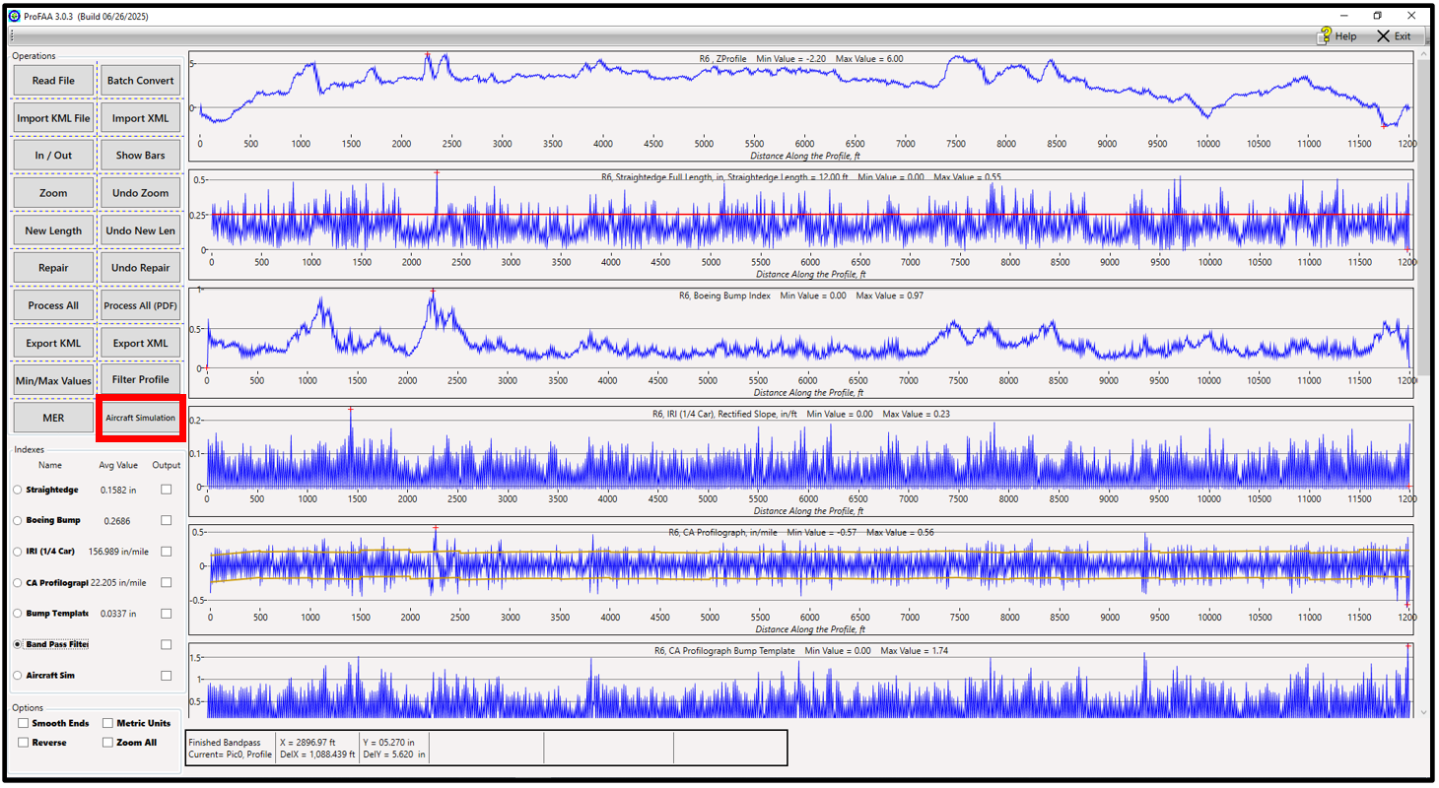
Figure 13. Selecting Aircraft Simulation Wizard from ProFAA main Interface

The Aircraft Simulation Wizard consists of five pages:
- Page 0: File Selection
- Page 1: Aircraft Selection
- Page 2: Input Parameters and Simulation Type
- Page 3: Simulation Input Summary
- Page 4: Simulation Output Summary

Page 0: File Selection
This profile selection window enables the user to select PRO files and select between English or Metric units, and is included as part of the process, to simplify the workflow for users analyzing multiple profiles with the same general simulation settings. An option is also available to select the profile currently loaded into the main ProFAA interface.
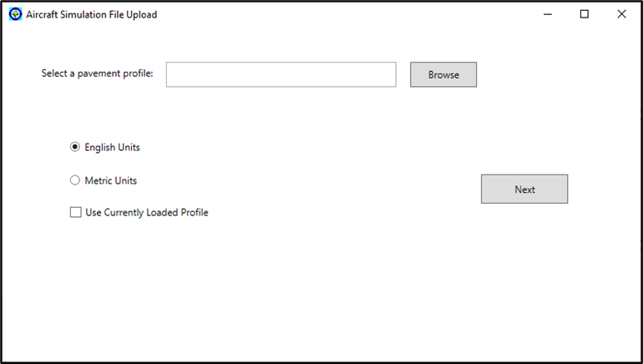
Figure 14. Screenshot of Aircraft Simulation File Upload Window

Page 1: Aircraft Selection
The first page of the Aircraft Simulation Wizard (see Figure 15) allows the user to select between seven aircraft classes and three gross weight choices for each aircraft. All of ProFAA-SD’s aircraft classes differ in gross weight and gear spacing. The user can choose from the following aircraft classes:
- Class GA (Prop): modelled after propeller driven general aviation aircraft
- Class GA (Jet): modelled after small general aviation jet
- Class RJ: modelled after regional jet
- Class NB: modelled after narrow body aircraft
- Class MM: modelled after middle market aircraft
- Class WB: modelled after wide body aircraft
- Class XL: modelled after extra-large aircraft
Each aircraft class has three gross weight options:
- Max Gross Weight
- 85% of Max Gross Weight
- 70% of Max Gross Weight
As the user selects their desired aircraft and gross weight, aircraft identifiers dynamically update to reflect the user’s selection. These aircraft identifiers include aircraft name, engine type, wheelbase (gear spacing), and gross weight.
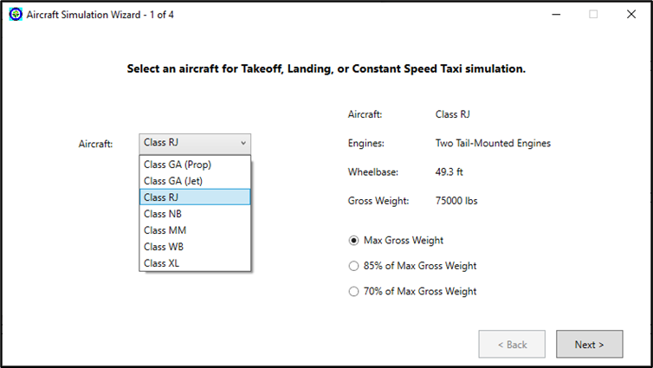
Figure 15. Aircraft Simulation Wizard, Page 1: Aircraft Selection

Page 2: Input Parameters and Simulation Type
The second page of the Aircraft Simulation Wizard (see Figure 16) is where the user can input simulation variables such as Headwind, Field Elevation, Air Temperature, and Simulation Starting Point. The user can also input the type of simulation to perform. The choices are Takeoff, Landing, and Constant Speed Taxi.
When switching between simulation types, there are some side effects that are programmed to occur on Page 2 of the Wizard. Next to the simulation types are non-interactable fields that display the aircraft type and gross weight. As real-life Landing operations have a lighter max gross weight than Takeoff operations, you can see the gross weight change as the user switches between simulation types. Real-life Landing operations also typically occur about 1500 ft (~500 m) down the runway, so if the Simulation Starting Point is 0 ft (0 m in Metric) on a Takeoff or Constant Speed Taxi operation and the user switches to Landing, the Simulation Starting Point will change to 1500 ft (or 500 m if the user chose Metric units). Similarly, when the user has Landing selected with a 1500 ft or 500 m Simulation Starting Point and the user switches to a Takeoff or Constant Speed Taxi operation, the Simulation Starting Point will switch to 0 ft or 0 m.
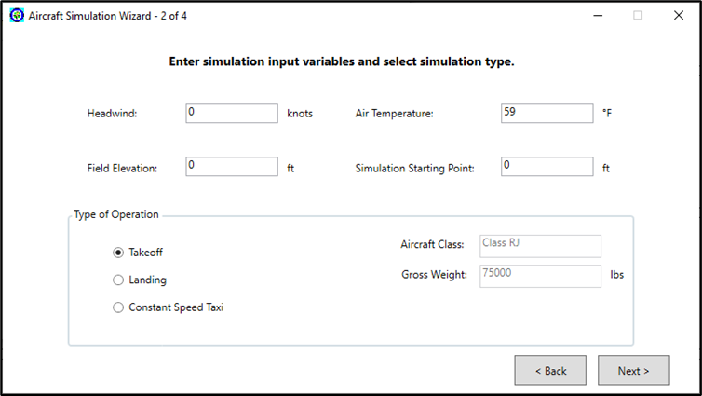
Figure 16. Aircraft Simulation Wizard, Page 2: Input Variables and Simulation Type

Page 3: Simulation Input Summary
The third page of the aircraft simulation wizard displays all the parameters input by the user for the current simulation. This page directly precedes running the simulation as a “Simulate” button can be found in the lower-right corner. This page also has a “Browse” button to select a location to save an optional simulation data file. The output file path will be displayed after the file save location is chosen in a copyable text field.
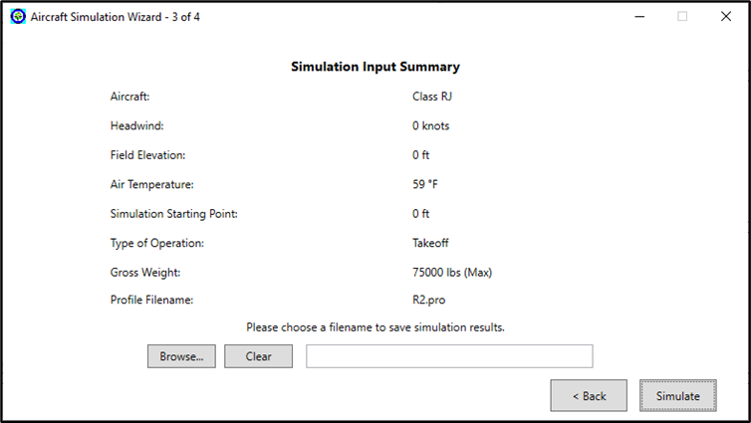
Figure 17. Aircraft Simulation Wizard, Page 3: Simulation Input Summary

Page 4: Simulation Output Summary
The fourth page of the aircraft simulation wizard appears when the simulation is done running. This page displays the simulation output summary containing general data about the simulation such as “Distance Traversed” and “Time Elapsed” as well as information on peak vertical accelerations and loads. Similarly to the third page of the wizard, the fourth page contains a “Save As” button to save a simulation data file. When the user clicks the “Done” button on this page, a prompt will appear asking the user if they would like to run another simulation. Clicking “Yes” on this prompt will return the user to the first page of the wizard to start another simulation with the same pavement profile. Clicking “No” on this prompt will close the aircraft simulation wizard. When the user clicks the “Plot” button, a separate plot window will open.
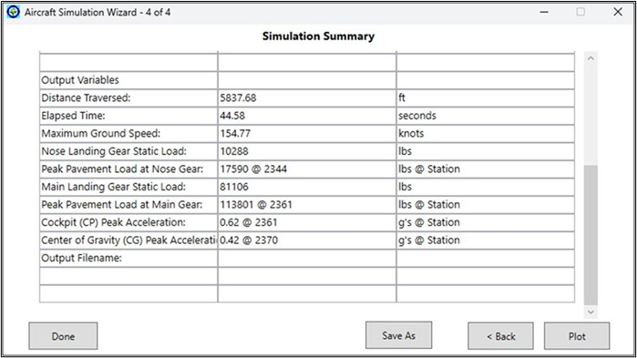
Figure 18. Aircraft Simulation Wizard, Page 4: Simulation Output Summary

Plot Window: Plot Content
The plot window displays the plotted results of the aircraft simulation as they relate to the pavement profile. Six charts are commonly displayed:
- Pavement profile as encountered by the main gear (in/mm)
- Cockpit Vertical Accelerations (CPA) (g’s)
- Center of Gravity Vertical Accelerations (CGA) (g’s)
- Nose Gear Vertical Loads (NGL) (lbs/N)
- Main Gear Vertical Loads (MGL) (lbs/N)
- Speed (knots)
When the Class XL aircraft is selected, seven charts are displayed as the main gear loads are broken up into two separate charts (to account for a four-posted aircraft):
- Main Gear (Body) Vertical Loads (MGBL) (lbs/N)
- Main Gear (Wing) Vertical Loads (MGWL) (lbs/N)

Plot Window: How to Read the Plot
As previously stated, the plotted profile is the pavement profile as encountered by the main gear. The nose gear plots (cockpit vertical accelerations and nose gear vertical loads) have been purposely plotted so that the data is set back by the length of the selected aircraft’s gear spacing. This explains why responses at the nose gear appear to happen earlier than the responses at the main gear and why the nose gear plots appear to “flat line” at the end of the simulation.

Plot Window: Functionality
When Zoom Mode is checked/on, clicking in two places on the same plot will zoom in on the profile between the two clicked points. When Zoom Mode is unchecked/off, clicking in two places on the same plot will display the distance between those two places as DelX and DelY. DelX and DelY display proper units depending on which plot was picked and whether English or Metric units are selected.
Grade refers to the slope of the profile from beginning to end. While PRO files already remove the grade from the pavement profile data, aircraft simulations usually only show a portion of the whole runway. The “Remove Grade” function changes the overall slope of the profile, so the profile starts and ends at 0 elevation (0 inches or 0 mm). The “Remove Grade” button’s text is changed to “Restore Grade” on click, signifying that the grade has been removed from the profile. Once “Restore Grade” is clicked, the profile will revert to its original state, also changing the button’s text back to “Remove Grade”.
The user may also choose to use zoom and remove grade features together in various combinations. Zooming in on a profile that already has the grade removed will zoom in on that grade removed profile. If you were to “Restore Grade” in any zoomed section of a grade removed profile, that zoomed section would be displayed as encountered by the original profile. Zooming and then clicking “Remove Grade” will show the removed grade of that zoomed section. In other words, the start and end of that zoomed section would both be at 0 elevation. When zooming and removing grade, the program stores the zoom level where the user removed grade . When the user clicks
Undo Zoom” at the zoom level that the grade was removed, the grade will be restored automatically, also reverting the “Restore Grade” button text back to “Remove Grade”.

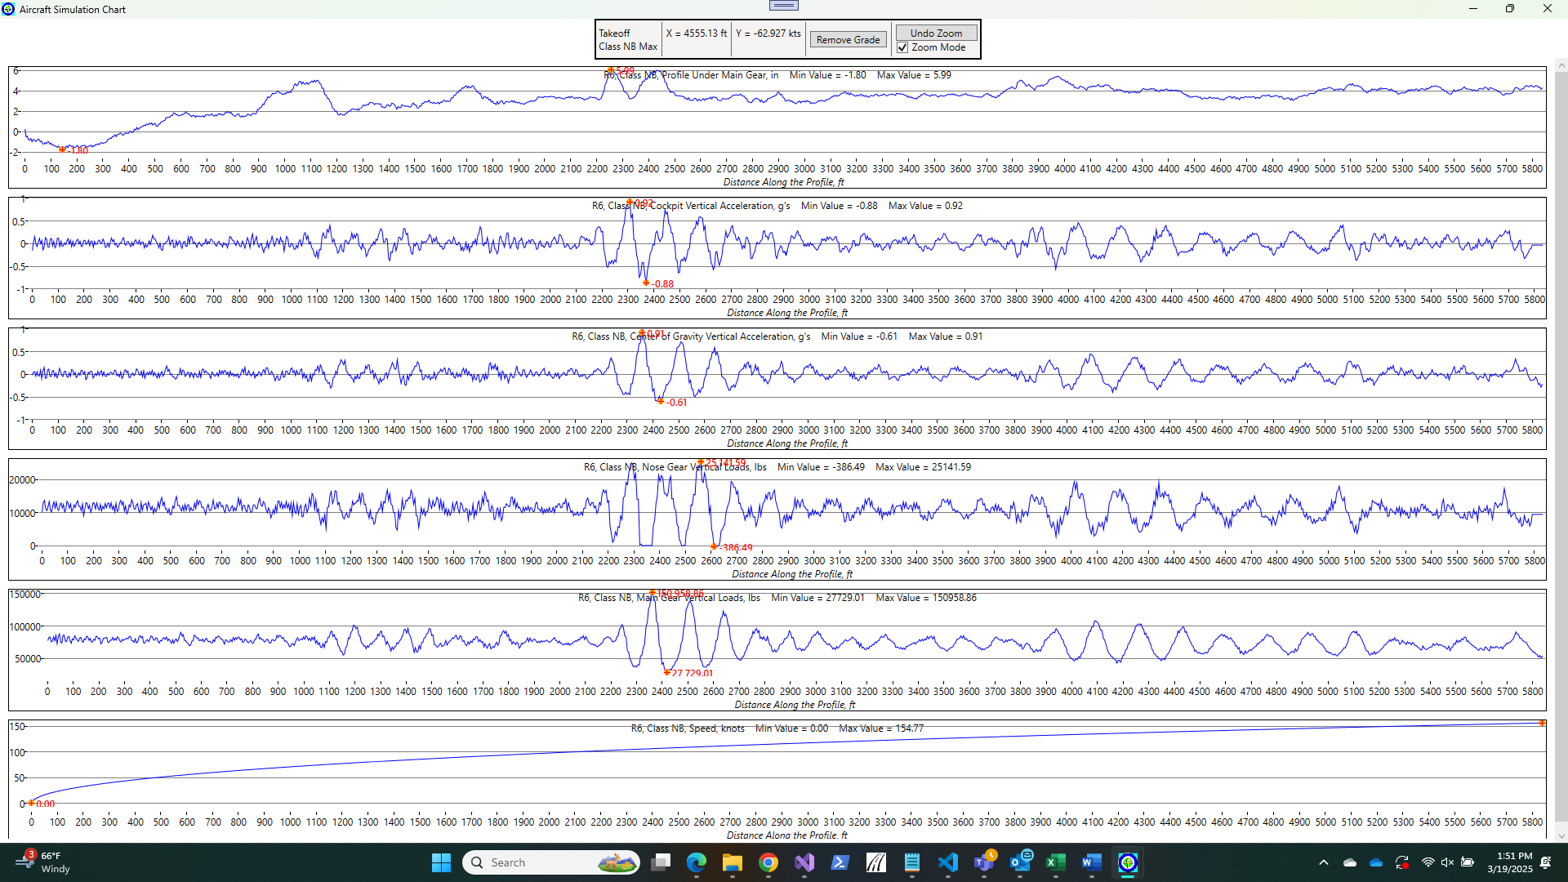
Figure 19. Aircraft Simulation Wizard: Plot Window

Aircraft Simulation: How to Select an Aircraft Class
When picking an aircraft class for simulation in ProFAA, which aircraft is best for the runway/taxiway being simulated depends on the context of the runway/taxiway being analyzed. If the user is analyzing a local general aviation runway, the user may consider simulating aircraft classes such as Class GA (Prop) or Class GA (Jet). If the user is analyzing a runway at an international airport, the user may consider using Class RJ, Class NB, or heavier aircraft classes depending on what aircraft operate out of the given airport. The user must weigh their options with gross weight, gear spacing, and airport operations in mind when selecting an aircraft class to simulate. It is best to simulate all aircraft classes that use that pavement.
ProFAA’s aircraft classes are generalizations of aircraft in that class and are not made to model a specific aircraft from that class. To match takeoff distances and landing roll out distances, thrust values have been fine tuned to match those distances found in reference materials, such as airport planning manuals, for those aircraft classes.

Aircraft Simulation: Additional Considerations
There are a few things to consider when using Aircraft Simulation. During Takeoff and Landing operations, it is possible to get a message stating “Insufficient runway length for takeoff” or a similar message for Landing. This means that the simulation was completed successfully but didn’t have enough distance from the starting point in order to reach Takeoff rotation speed or come to a stop in Landing. The user can reduce the aircraft weight to more accurately simulate the condition.
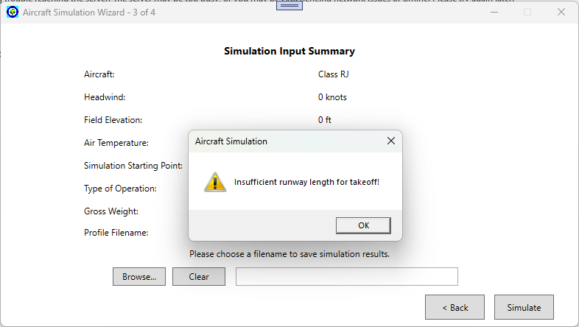
Figure 20. Aircraft Simulation: "Insufficient Rnway Length for Takeoff!" message

Conclusions
The FAA’s software for assessing airfield pavement roughness (ProFAA) has been modified to simulate Takeoff, Landing and Constant Speed Taxi operations on runways and taxiways for seven different classes of aircraft. The primary factors separating the aircraft classes are weight and landing gear spacing. Table 1 defines the seven aircraft classes.
The equations of motion that compute the aircraft’s dynamic responses are basically the same for all aircraft classes. However, specific parametric data is required for each aircraft class. These include strut characteristics, tire pressures, gear spacing, weights and inertias, etc. The data used for these seven aircraft classes are based in part on aircraft data from APR’s comprehensive aircraft database.
The upgraded ProFAA software will enable users to more effectively evaluate airport pavements for:
- Smoothness acceptance
- Roughness evaluation
- Determine the need for corrective action
- Design repairs
- Evaluating repair effectiveness
The upgraded ProFAA software works in conjunction with the recently developed MER (Multiple Event Roughness) evaluation tool. MER locates and quantifies roughness events using measured profile data only. MER is a part of pavement management programs and periodic inspections. Once an MER analysis finds an event that is excessive or unacceptable, the upgraded ProFAA software provides an enhanced tool for making informed decisions regarding corrective action decisions. This concept has been referred to as the “Pavement Preservation Loop” (PPL). The PPL is intended to help meet the FAA’s goal of the “Forty Year” pavement.

Observations and Lessons Learned
What are the key factors that impact how an aircraft responds to a given area of roughness?
- The wavelength of the bump
- Speed of encounter
- Single bump or multiple bumps in succession
- Operation type: takeoff, landing or taxi
What are the more important aircraft characteristics?
- Landing gear spacing
- Weight
- Strut pre-charge pressure, load-stroke curve
- Tire pressure
- Pitch inertia
- CG location

Potential Additions to ProFAA
- Roll degree of freedom (DOF): Adding a roll DOF would enable the user to simulate a different measured profile under each landing gear. This would require significant changes to the equations of motion. A roll DOF would be more realistic particularly when traversing an intersecting runway that is at an angle to the direction of travel.
- Rejected takeoff: Adding the capability to simulate a high speed rejected takeoff would allow the user to simulate this emergency operation. The rejected takeoff is an infrequent operation and is a stressful maneuver on the aircraft structure. The aircraft is heavy; it may have little runway remaining to get stopped and therefore demand very heavy braking and reverse thrust. Typically, the aircraft will pitch over on the nose landing gear strut and tires loading them up. This addition to ProFAA would also require significant changes to the equations of motion.
- Enhancing “Repair” tool: There are many features in ProFAA that could benefit from additional functionality, such as the Pavement Repair feature. Currently, the repairs made with the repair tool only influence the “indexes” in the ProFAA main window and do not change the profile as encountered by MER or Aircraft Simulation. The user could also benefit from the ability to export their repaired profile for later analysis. Adding additional repair methods could help emulate more realistic repairs as ProFAA currently only uses a straight-line repair tool. This addition to ProFAA would not require changes to the equations of motion or aircraft data.
- Develop a Training Webinar: The recent additions of the MER analysis and takeoff and landing simulation capability are significant enhancements to ProFAA. ProFAA users would be provided with training on the complexities of the upgraded software. “Hands-on” training would enhance their ability to analyze a pavement.
Webinar topics could include:
  - Best practices for measuring a profile and conducting an MER analysis
  - Best practices for profile file naming strategies
- Deciding what class(es) of aircraft to simulate in an analysis
- Tips impacting corrective action decisions
- Special topics: field elevation, hot-cold day, headwind, intersection takeoff…
- Tracking “Roughness Growth”
- Predicting pavement remaining life
- Determine effectiveness of a proposed repair
A ProFAA training webinar could be offered several times a year. The vision is to provide background information on the MER process, takeoff and landing development, and how it all ties together with pavement management practices. Users would have a better understanding of the Pavement Preservation Loop (PPL) idea and how proactive corrective action contributes to the FAA’s 40-year pavement goal.
- Add CREATE: APR developed and has used a program called CREATE to generate runway profiles. It will produce almost any bump configuration desired. The current program in APRas will generate a profile of any length with (1-COS) bumps or dips, up or down ramps, and up or down step bumps. This tool is useful for conducting parametric studies and could be used for simulating repair configurations for proposed corrective action, to design intersection crowns, to design temporary ramps or for general research. This APRas software tool could be added to ProFAA.
- Add a PSD (Power Spectral Density) analysis to the MER operation. This would identify roughness events like those found on Taxiway T38 (Figure 40 in Appendix A) that were causing pilot complaints. This roughness was not detected by MER because the amplitudes were so small but were repeated continuously. Consider adding a PSD analysis as an additional MER operation tool.
Consider a project to collect additional profile data for taxiways and GA runways. There is a need to expand on the empirical data that was used to develop the limits of acceptability for these types of pavements.

Recommendations
To achieve the FAA’s goal for a “40 Year Pavement”, it is recommended that FAA Advisory Circulars FAA AC 5380-9 and FAA AC 5380-7 include updated guidance to periodically measure and evaluate airport pavements using the tools recently developed for ProFAA. This “Pavement Preservation Loop” concept will enable users to make corrective actions early and extend pavement life. Maintaining smooth pavements also reduces aircraft fatigue damage and operational costs.
Many upgrades have been made to ProFAA under the current BAA in the last 3 years. It is recommended that a training webinar be designed and then presented semi-annually to familiarize potential users with hands-on experience.
Potential additions to ProFAA capabilities such as rejected takeoff, use of three lines of survey, or enhanced pavement repair tools are natural follow-on efforts. If it is anticipated that these features are to be added, maintaining continuity with the current development of the equations of motion is recommended.

References
- Gerardi, T. and Gerardi, M. (2023, January) “Method to Identify and Quantify Multiple-Event Roughness” DOT/FAA/TC-23/09 (Phase 1 Final Report).
- Gerardi, T. and Gerardi, M. (2024, August) “Airport Pavement Multiple-Event Roughness Detection and Evaluation”: Report number: DOT/FAA/TC-24/14 (Phase 2 Final Report).
- Boeing Commercial Airplane Group, Airport Technology Organization. (1995, November). Runway roughness measurement, quantification, and application - Boeing method (Document https://www.boeingsuppliers.com/assets/pdf/commercial/No. D6-81746).
- Federal Aviation Administration (FAA) (2014, Oct). “Guidelines and procedures for measuring airfield pavement roughness.” Advisory Circular [AC] 150/5380-9). https://rosap.ntl.bts.gov/view/dot/66301/dot_66301_DS1.pdf
- Federal Aviation Administration (FAA) (2009, September 30). Airport Pavement Management Program (PMP). (Advisory Circular [AC] 150/5380-7B https://www.faa.gov/airports/resources/advisory_circulars/index.cfm/go/document.current/documentNumber/150_5380-7.
- Federal Aviation Administration (FAA) AC 150/5300-13, Airport Design. https://www.faa.gov/airports/resources/advisory_circulars/index.cfm/go/document.current/documentNumber/150_5300-13.
- Typical Example of an Airport Planning Manual, Bombardier Inc. https://customer.aero.bombardier.com/webd/BAG/CustSite/BRAD/RACSDocument.nsf/51aae8b2b3bfdf6685256c300045ff31/ec63f8639ff3ab9d85257c1500635bd8/$FILE/ATTQF1EY.pdf/CRJ900APMR11.pdf.
- Typical Boeing Airplane Characteristics for Airport Planning https://www.boeing.com/content/dam/boeing/boeingdotcom/commercial/airports/acaps/777X_RevB.pdf.

Appendix A: Results of Field-Testing MER Analysis
Phase 2 of this BAA research effort developed a method to locate and quantify Roughness using measured profile data only. The results are presented in color-coded 500-foot sections. It is commonly referred to as the “MER” (Multiple Event Roughness) operation in ProFAA. The “Limits of Acceptability” were established in Phase 2 using empirical data from over 100 different sets of profile data.
In Phase 3 of this study, the Task 3.1.6 objective was to field-test the MER method and the limits of acceptability by applying the ProFAA operation to additional profile data as they became available to APR Consultants.
Seventeen (17) runway profiles were evaluated under this task: R212, R41, R13, R42, R43, R301, R302, R303, R401, R402, R 501, R503, R504, R44, R601, R701, and R801. Three taxiways T38, T39 and T40 were evaluated with the MER tool.
Table 7 contains the limits of acceptability established empirically in Phase 2. One of the goals of this “field-testing” task was to determine if the limits are a reasonable reflection of the in-service runways in the air transport system. The intent of the limits of acceptability is to identify runway and taxiway sections that should be considered for corrective action (Red or Yellow) and those that are currently acceptable (Green). Sections identified for potential corrective action are further evaluated using additional tools in ProFAA such as aircraft simulation. These tools enable the user to make informed decisions regarding the urgency of a repair and the optimization of a repair. The triad approach (inspect, evaluate, repair) led to the Pavement Preservation Loop concept illustrated in Figure 1.
Table 7. ProFAA Roughness Limits of Acceptability.
The Figures in this appendix show the color-coded roughness results of runway profiles that have been measured during Phase 3 of this research effort. Each figure contains the computed values for each pavement section for each assessment tool.
- PI-100 detects Type 3 roughness: uses a 1-inch blanking band (BB)
- PI-25 detects Type 2 roughness: Uses a .4-inch blanking band (BB)
- RSE detects Type 1 roughness: deviation from a 12-foot rolling straightedge
- BBI detects the deviation from the Boeing Bump Index Chart.
Taxiway evaluations are limited to PI-25 and the 12-foot straightedge analyze. BBI does apply to taxiways and PI-100 is not useful since speeds are low and controllable on taxiways.

Runway R212
Runway R212 is an asphalt runway 7700 feet long that has significant Type 3 roughness in the first 3500 feet. It is a military runway used primarily for UAV aircraft. Figure 21 is a screen shot of the MER Roughness Analysis of Runway R212.
- The roughness of R212 was primarily Type 3.
- Results are consistent with the current limits of acceptability
Figure 21. Screen Shot of a Roughness Analysis of Runway R212.
Runway R41
Runway R41 is built on reclaimed ground and is known to have differential settlement issues. This runway had very long wavelength Type 3 roughness caused by settlement.
A roughness evaluation using 2024 survey data of R41 yielded a potential shortcoming in the current limits used to determine the MER values. As seen in Figure 22 the MER PI-100 tool in ProFAA failed to detect the longer wavelength bump event in Section 19. The PI-100 index value in Section 19 was 17.54. The threshold for yellow is 20. The roughness was detected by the BBI tool, but BBI does not consider multiple events. Boeing uses a maximum of 200 feet (half wave) for the BBI analysis. This is why it detected the event as excessive.
This is an uncommon occurrence and is only an issue at high speeds for aircraft with a long wheelbase. For these special conditions, it may be worth considering adding a longer analysis tool such as a PI-400 to the MER analysis.
FAA AC 150/5380-9 states “The Boeing Bump procedure considers straightedge lengths (wavelengths) up to 120 meters (394 feet). Because the Boeing Bump procedure targets isolated bump events, “wavelength” terminology is replaced with “bump length”. Research cited by Boeing has demonstrated that bump lengths in excess of 120 meters (394 feet) do not contribute to dynamic airplane response or negatively impact the airplane.”
It may be worth considering adding a PI-400 to the current MER analysis tool kit. PI-400 is consistent with the Boeing 394 feet (120 meters) and would detect the longer wavelengths caused by differential settlement and the roughness caused by the crowns at runway intersections. Adding this new tool would require establishing a limit of acceptability for PI-400.
Figure 22. Screen Shot of a Roughness Analysis of Runway R41.
Runway R13
Similar to R212, Runway R13 (Figure 23) is a unique case. This is the profile of a new asphalt runway overlay. The profile was measured on 25-foot increments, consequently a lot of Type 1 and Type 2 roughness may have been missed. Overall, it is smooth except for Sections 9 and 10. This area is an out-of-service runway intersection that has a typical crown for dispersing water. The overlay design did not include removing the crown. Since the runway was no longer active, removing the crown would have been preferred. As a result, the intersection caused long wavelength Type 3 roughness. Similar to Runway R212, BBI detected the bump, but PI-100 did not. A PI-400 assessment tool in ProFAA would have detected this event.
R212 and R13 are both uncommon situations, and even though PI-400 would resolve the issue, it is recommended that PI-400 be considered for implementation into ProFAA. The large majority of pavements analyzed using the current MER analysis tools detect the roughness that impacts aircraft response.
Figure 23. Screen Shot of a Roughness Analysis of Runway R13.
Runway R42: Runway R42 (Figure 24) is an asphalt runway that was causing pilot complaints during takeoff on Class WB aircraft. The cause was the crown of an intersecting runway. R42 is the runway used for validation purposes (Figures 11 and 12 above).
Figure 24. Screen Shot of a Roughness Analysis of Runway R42.

- The roughness of R42 at the intersection was multiple Type 3 bumps.
- The roughness on the 23 end was Type 3 as well, but caused no complaints probably because of the location.
- The roughness in sections 11, 17 and 18 were very mild Type 3.
- Results are consistent with the current limits of acceptability.
Runway R43
Figure 25. Screen Shot of a Roughness Analysis of Runway R43.
Runway R43 (Figure 25) had significant Type 2 and Type 3, and BBI roughness in and around the crown of the intersecting runway. It does not cause pilot complaints because of its location (1,000 feet from the 15 end). Aircraft would land past that point and would have a low speed during a takeoff roll. This bump would not be an issue except in the rare case of a high-speed aborted takeoff from the 33 end.
- The roughness of R43 at the intersection in Section 3 was Type 2 and Type 3 roughness.
- The roughness in Section 6 was a Type 1 Rolling Straightedge event
- Results are consistent with the current limits of acceptability

Runway R301
Runways R301, R302, and R303 are three runways at the same airport. R301 and R302 are strictly for GA aircraft operations. R303 is for commercial operations.
Figure 26. Screen Shot of a Roughness Analysis of Runway R301.
Runway R301 (Figure 26) is a 4,300-foot runway and would be unacceptable for commercial aircraft operation. Primarily because it has two very rough intersections in the first 2,000 feet. This runway is currently in service but is used only for GA operations. GA aircraft are less susceptible to Type 2, Type 3, and BBI roughness.
- The roughness in the first half of R301 is very significant Type 2 and Type 3 roughness and would not be acceptable for commercial aircraft operations.
- Runway R301 MER results suggest that GA aircraft should consider different limits of acceptability. The IRI (International Roughness Index) method used for roads and highways or a PSD analysis may apply better to GA operations. IRI and PSD limits specifically derived for airports (GA operations) would need to be developed.
- The MER limits of acceptability results are consistent for commercial aircraft operations.

Runway R302
Runway R302 (Figure 27) is parallel to R301 and is also a 4,300-foot runway. It is smoother than R301 but would still be unacceptable for commercial aircraft operation. Primarily because it has Type 2 and Type 3, and BBI roughness in the first 2,000 feet. This runway is also currently in service but is used only for GA operations. GA aircraft are less susceptible to Type 2, Type 3, and BBI roughness.
- The roughness in the first half of R302 is significant Type 2 and Type 3 roughness, is smoother than R301, but would not be acceptable for commercial aircraft operations.
- Runway R302 MER results also suggest that GA aircraft should consider different limits of acceptability. The IRI or PSD analyses may apply better to GA operations.
- The MER limits of acceptability results are consistent for commercial aircraft operations.

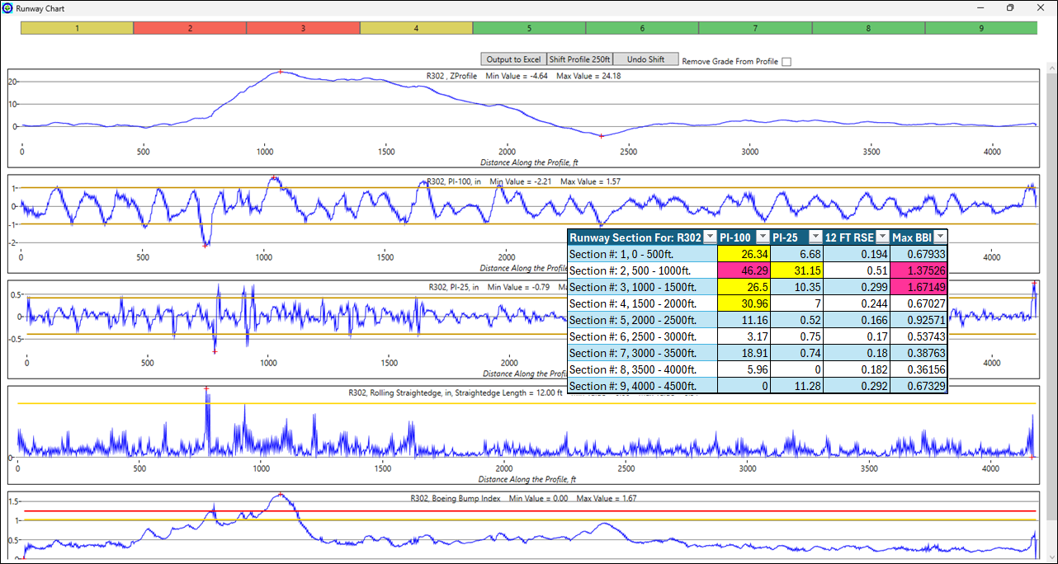
Figure 27. Screen Shot of a Roughness Analysis of Runway R302.
Runway R303
Runway R303 (Figure 28) is the third runway at this airport and is used for commercial operations. It is an asphalt runway 6,300 feet long. It is acceptable for commercial and GA operations.
- The roughness in the first section is a Type 1 rolling straightedge roughness and is located at the very end of the pavement where the paving started. It is not a concern. The last section also had a Type 1 rolling straightedge roughness event of 19.46. This should have been labeled acceptable (green). It is believed it was labeled yellow because of roundoff assumptions. The threshold is 20.00.
- The MER limits of acceptability results are consistent for commercial aircraft operations. There was one exception using the rolling straightedge in Section 13.
Figure 28. Screen Shot of a Roughness Analysis of Runway R303.
Runway R401
Runways R401 and R402 are two intersecting runways at the same airport. The profiles were measured in October 2025 using an Ames high speed profiler. R401 is the primary runway. Runway R401 (Figure 29) is 10,000 feet long and all sections were found acceptable.
Figure 29. Screen Shot of a Roughness Analysis of Runway R401.
- The roughness in R401 shows all green; no roughness identified.
- The MER limits of acceptability results are consistent for commercial aircraft operations.
Runway R402
Runway R402 (Figure 30) is a 6,000 foot runway that has mild roughness in and around the intersection with the primary runway.
Figure 30. Screen Shot of a Roughness Analysis of Runway R402.
- The roughness in Sections 5 exceeded the PI100, PI25, RSE and nearly exceeded the BBI thresholds.
- The MER limits of acceptability results are consistent for commercial aircraft operations.
Runway R501, R503 and R504
Runways R501, R503, and R504 are at the same airport. They are all asphalt construction and are all built on reclaimed ground. Some portions of each runway are built on solid ground and some portions are not. This fact impacts the longitudinal differential settlement.

Runway R501
Runway R501 (Figure 31) was constructed in 1998 and has had multiple overlays since its original construction. The most recent overlay was in 2023.
Figure 31. Screen Shot of a Roughness Analysis of Runway R501.
- This runway had very mild PI100 exceedances in Sections 6 and 14. This runway is smooth and is acceptable for normal operations. The two yellow sections would be areas to monitor in future inspections.
- The limits of acceptability results are consistent for commercial aircraft operations.
Runway R503
R503 (Figure 32) is a newly constructed runway at this airport. This is the first time APR has assessed the profile.
Figure 32. Screen Shot of a Roughness Analysis of Runway R503.
- Runway R503 had very mild PI25 exceedance in Section11 and an RSE exceedance in Section 10. This runway is smooth and is acceptable for normal operations. The two yellow sections would be areas to monitor in future inspections.
- The limits of acceptability results are consistent for commercial aircraft operations.

Runway R504
R504 (Figure 33) is one of the original runways constructed at this airport in 1998. It has been resurfaced several times and has had many asphalt (patching) type repairs. This is reflected in the MER analysis as PI25 exceedances. This runway would likely be considered as mild to moderately rough by pilots operating on it. Additional ProFAA analyses such as aircraft simulations would recommend monitoring these pavement sections and considering corrective action sometime in the future.

Figure 33. Screen Shot of a Roughness Analysis of Runway R504.
- Runway R504 had PI25 exceedance in four sections and RSE exceedance in three sections. This runway has patch repairs which are reflected by the PI25 and RSE exceedances.
- The limits of acceptability results are consistent for commercial aircraft operations.

Runway R44:
R44 (Figure 34) is the smoothest runway APR has ever measured and is shown as a “smooth runway” reference. It is a concrete runway that was built using precision lasers for grade control and additional smoothness related technologies. This runway was measured as part of the FAA’s runway profiler study conducted in 2021. The profile was measured with the APR’s Auto Rod & Level-ER, the SurPRO and the AMES high speed profiler.
- The limits of acceptability results are consistent for commercial aircraft operations.

Figure 34. Screen Shot of a Roughness Analysis of Runway R44.
Runway R601:
Runway R601 (Figure 35) is an older military PCC runway that has been well maintained. Section 12 however, has a deactivated arrestor barrier that caused the MER analysis to identify that section as red with a PI100 of 37.7.
- The limits of acceptability results are consistent for commercial aircraft operations.

Figure 35. Screen Shot of a Roughness Analysis of Runway R601.
Runway 701:
APR was asked to conduct a BBI assessment of a commercial runway that was generating pilot complaints of roughness. The BBI analysis shows the rough area fell into the “acceptable” range. However, a ProFAA-MER analysis showed section 3 to be unacceptable with a PI-100 of 52.95. This runway is an example of how the location of the rough area is critical in determining its acceptability. Figure 36 is a screen shot of a BBI analysis of Runway R701. Figure 37 is a screen shot of the MER analysis of Runway R701. The bump in section 3 is obvious in the MER plot. The ProFAA Class RJ takeoff simulation shown in Figure 38 predicts a cockpit acceleration of .87g’s and a CG acceleration of .47g. The nose landing gear hit this bump at 75 knots.
- Runway R701 exceeded the limits of acceptability in multiple sections.
- The limits of acceptability results are consistent for commercial aircraft operations.

Figure 36. BBI Analysis of Runway R701 “Acceptable”.
Figure 37. Screen Shot of Runway R701 MER Analysis.
Figure 38. Screen Shot of a Class RJ Takeoff Simulation on Runway R701.
Runway R801
Figure 39 is an MER analysis of Runway R801. This is a very smooth newly paved asphalt runway. The profile was measured with an Auto Rod & Level-ER. All MER assessment tools confirm this to be a smooth pavement.
- Runway R801 did not exceed the limits of acceptability.
- The limits of acceptability results are consistent for commercial aircraft operations.

Figure 39. Screen Shot of MER Results of Runway R801.
Taxiway T38
Taxiway T38 (Figure 40) was measured 19 August 2025 with a high-speed inertial profiler. Pilots were complaining of roughness. This is an older PCC taxiway. It is suspected that dowel bars connecting the slabs had failed. T38 was the only pavement that clearly did not detect the roughness that pilots were complaining about. However, a PSD (Power Spectral Density) analysis clearly identified the 20-foot repeated events. Figure 41 is an expanded profile plot showing the repeated roughness on 20-foot intervals. Figure 42 shows the PSD analysis results.
- Taxiway T38 did not detect the roughness causing pilot complaints
- It is recommended that the MER analysis include a PSD analysis.
Figure 40. Taxiway T38 MER Operation Not Successful in Detecting Pilot Reported Roughness.
Figure 41. Expanded Plot of a Section of Taxiway T38.

Figure 42. PSD Plot of Taxiway T38.

Taxiway T39
T39 and T40 (Figure 43 and 44) are full-length parallel taxiways. The intersection where T39 and T40 meet was scheduled for corrective action prior to the profile measurements in the fall of 2025. The MER analysis successfully identified the areas needing the repairs.
Figure 43. Screen Shot of Taxiway T39.
- Taxiway T39 exceeded the limits of acceptability in Four Sections. These Section Had Been Scheduled for Repairs
- The limits of acceptability results are consistent for commercial aircraft operations
Taxiway T40
Figure 44. Screen Shot of Taxiway T40.
- Taxiway T40 exceeded the limits of acceptability in two sections.
- The limits of acceptability results are consistent for commercial aircraft operations

Task 3.1.6 Conclusion: Task 3.1.6 of this BAA study field-tested the MER analysis method on 17 runway profiles and 3 taxiway profiles. The limits of acceptability were valid for all profiles tested with few exceptions. Taxiway T38 clearly did not detect roughness that pilots were complaining about. The roughness is picked up however with a PSD analysis. It is recommended that PSD be considered as an additional MER evaluation tool.
BBI is calculated as an “Index” currently calculated in ProFAA. It is also being computed in MER as well. This is an unnecessary duplication. It is suggested that a PSD computation be considered to replace the BBI analysis in the MER “Operation”. This would require the development of PSD “Limits of Acceptability”. It is also recommended that more taxiway profile data (concrete pavements in particular) be measured to develop the limits of acceptability for taxiways.
In certain cases, like Runway R-13 and R212, BBI detected very long wavelength bumps that PI100 did not. These bumps could cause pilot complaints on larger aircraft if encountered at very high speeds. An additional tool to the MER evaluation process may be worth considering: a simulated 400-foot long profilograph (PI-400) would identify the roughness on R13 and R212. Adding a PI-400 modification to the ProFAA MER analysis would require defining additional limits of acceptability for the PI-400.
The ProFAA MER operation tool combined with updated FAA advisory circulars FAA 150/5380-7 and FAA 150/5380-9 offers the user an opportunity to make informed decisions regarding corrective action. In cases such as Runway R-43 where the MER revealed rough areas, a ProFAA takeoff simulation shows that corrective action was not needed because the bump was encountered at a low speed. It is recommended that the Pavement Preservation Loop concept (Figure 1 in the introduction) be implemented and incorporated into the applicable advisory circulars as the next step towards the 40-year pavement goal.

